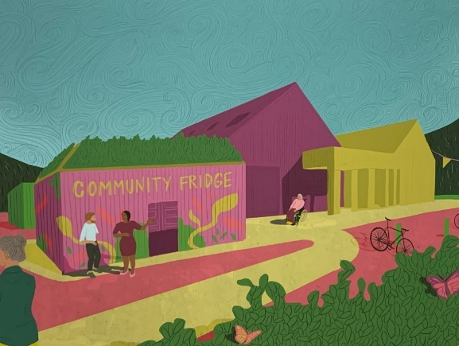
At the Larick Centre we have a Community Fridge, which enables us to redistribute and share food and period products with fridge users. This helps us combat food waste, save money and connect to our community.

It is open to everyone and it is donation based. If you can’t spare any cash then take what you need, if you can then donate and help us to keep providing this service for all.

Every week there will be different surplus food distributed by Fareshare Tayside & Fife, who receive the products from various supermarkets. We also collect surplus food from local shops in and around Tayport and receive donations from individuals. Fife Council supported us with a fridge and freezer to keep the food fresh and for longer.

Individual households can also donate, we can take: Fruit and veg (as long as it hasn't been cut/prepared/cooked), long-life and unopened foods such as pasta, cereal and tins that are no more than 6 months past their BEST BEFORE date. Unfortunately, we cannot accept any items with a USE-BY date from individuals as they are high-risk.

Together with other Community Fridge initiatives we became part of the North East Fife Community Fridge Network supported by Fife Council

Come along to the Larick Centre on Fridays 3-4pm and help yourself to food and products and help reduce your carbon footprint.

